GSTA Internet
Outlook 2003 - 2007 Email configuration
Aug 2011

Description and foreword:

All authorized customer of GSTA Internet can use the email systems to access their email via a web browser or Outlook 2003/7/10 or MAC with Entourage 2008. The following document describes how to access and configure your email. Please note that your username and password are private and should not be given to anyone else. Any abuse or illegal use of the email system will be ground for immediate termination.

Prerequisites (Outlook 2003 - 2007):

- You must have a working internet connection.
- Windows XP with service pack 2 or Vista SP1.
- Office 2003 with service pack 2 installed or Outlook 2007.
- A valid email account assigned by the corporate office.

Webmail access:

To access the webmail you can logon at any computer that has internet access. Then just enter the following url in the address bar of the internet browser:
http://exchange.gsta.net/exchange
You will be prompted for your username and password.
Once you have entered your username and password the screen will be self explanatory and contain all your email, contacts and calendar. Please note that the functionality of the address book is different in webmail from outlook. .

Outlook 2003 configuration:

To configure outlook 2003 you must complete the installation of the secure certificate into your internet explorer then configure outlook.

- Outlook configuration
  - Go to the control panel and click on the mail icon (fig. 1) Note that if you don’t see the mail icon then look at the left side of the screen and click [Switch to classic view]. If you still can’t see the mail Icon then this must be the first time that you setup outlook in your computer, if so then close the control panel and double click on Outlook Icon and follow the steps to add a new Microsoft Exchange Account..

Fig. 1
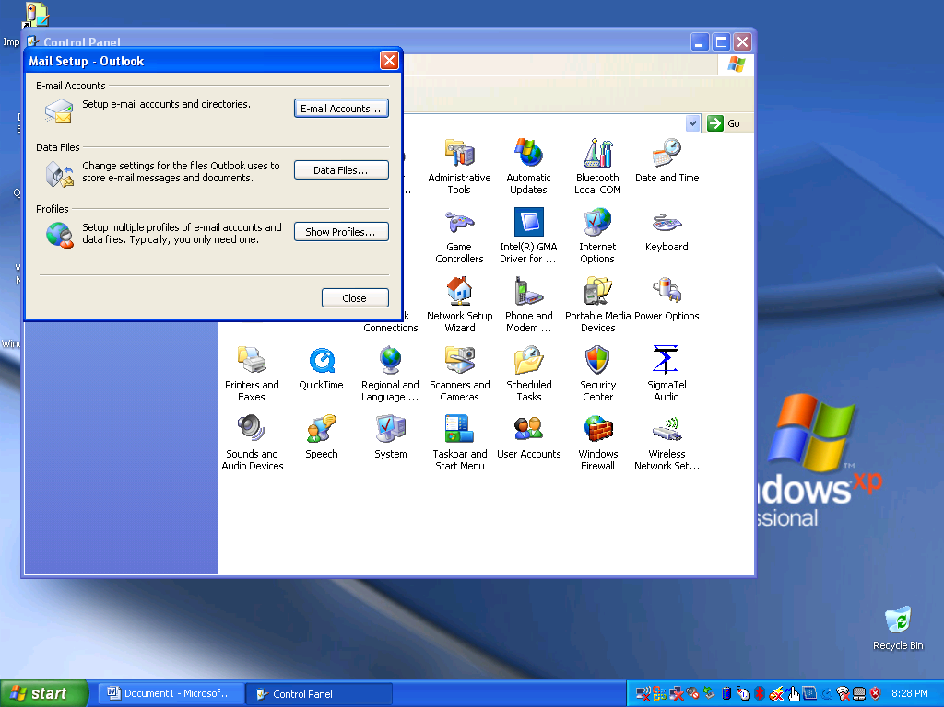

  - Click on the button that says [E-mail accounts]
  - Select the radio button that says [Add a new e-mail account] and click [Next]. Fig. 2

Fig. 2
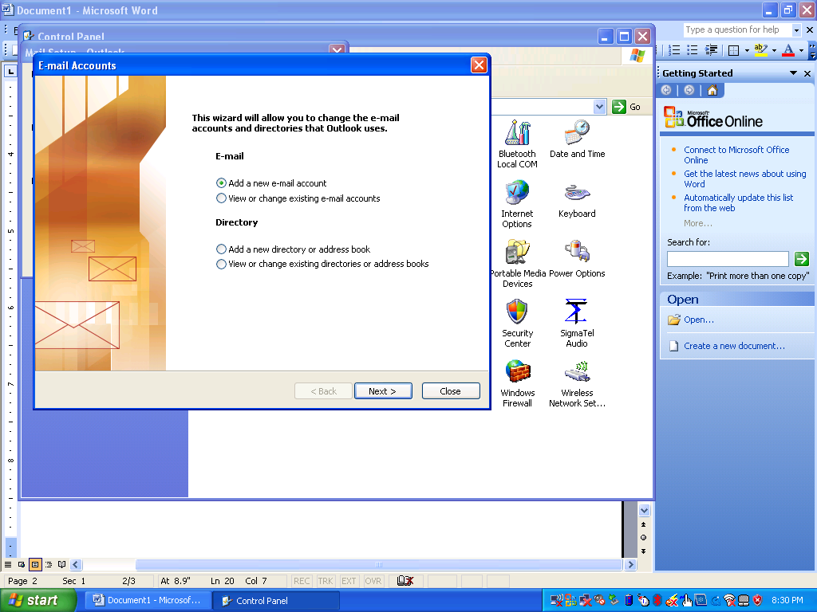

  - Select the radio button [Microsoft Exchange Server] and click [Next]. Fig. 3

Fig. 3
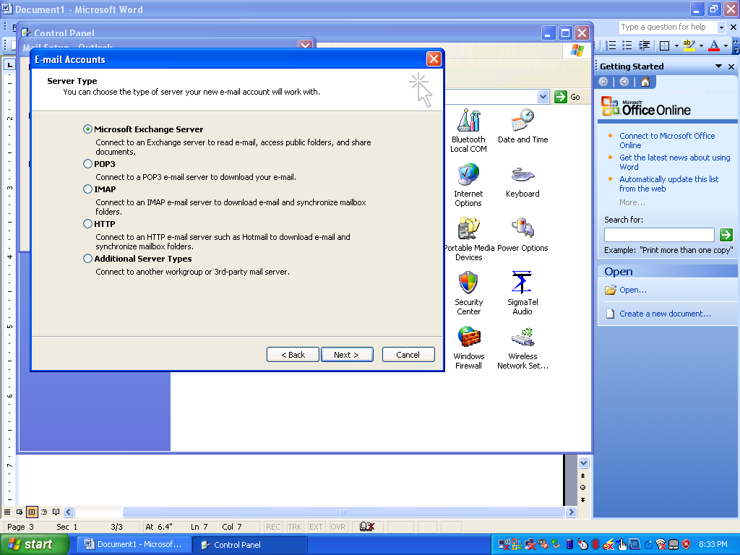

  - Enter the following information for the Microsoft Exchange Server: mail.exchange.gsta.local
Leave the box checked that says Use Cached Exchange Mode
Enter your username as assigned by the corporate office.
Note: if you get prompted by a popup box for your username and password, please click cancel for now. Fig. 4

Fig. 4
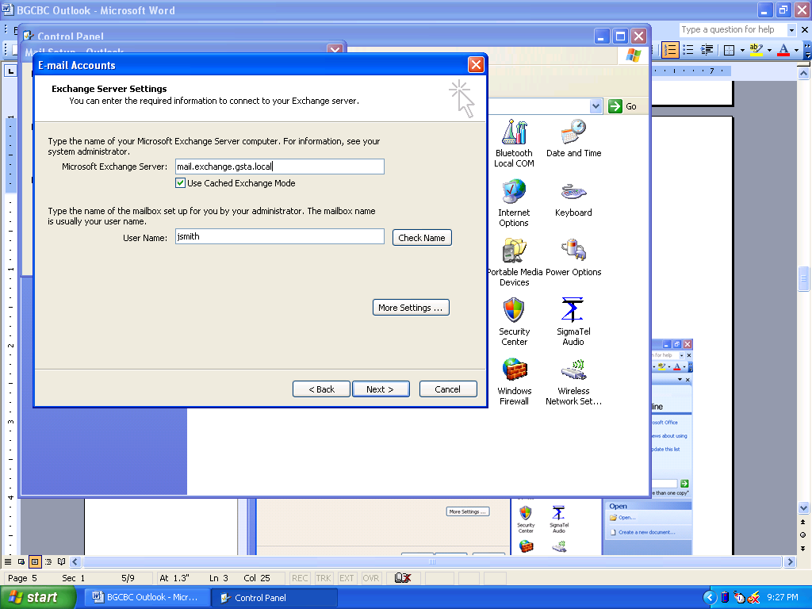

  - Click on the button that says [More Settings…]
  - Once you enter the more settings area click on the tab [Advanced]
  - Check the box that says Download Public Folder Favorites [x] Fig. 5

Fig. 5
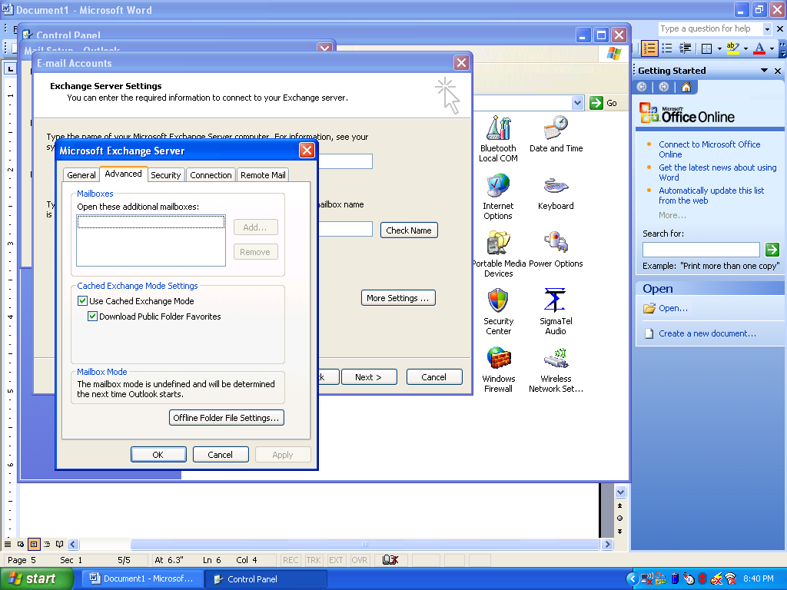

  - Click on the [connection] tab.
  - Check the box that says [Connect to my Exchange mailbox using http] [x]
  - Click on the button that says [Exchange Proxy Settings…] Fig. 6

Fig. 6
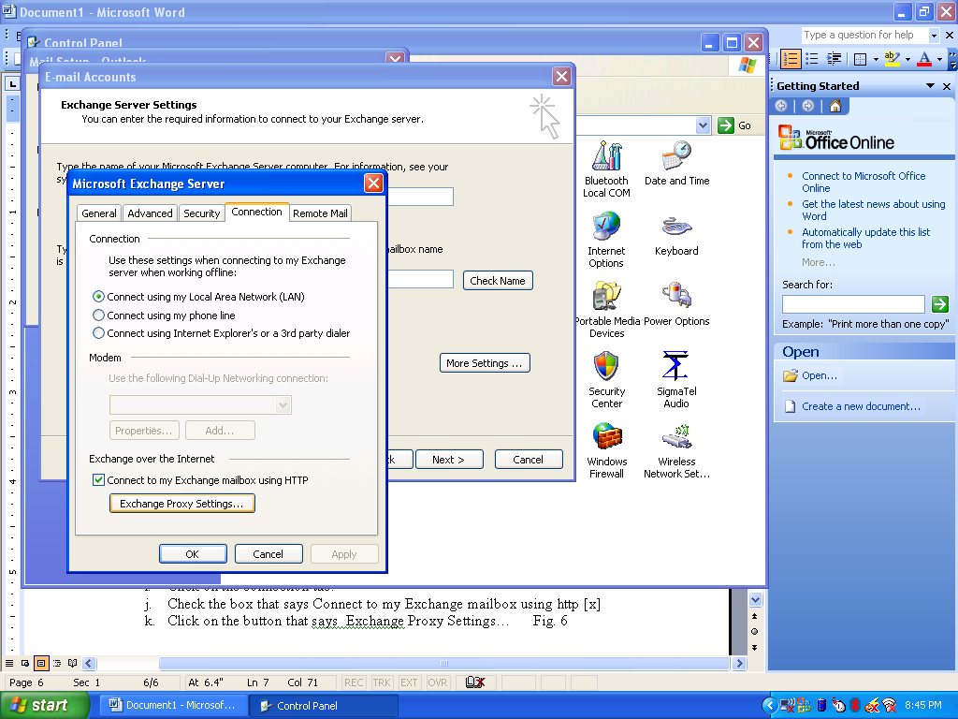

  - In the box that says [Use this URL to connect to my Exchange server] enter the following: exchange.gsta.net
  - Check the box that says [Mutually authenticate this session when connecting with SSL]
  - In the box that says [Principal name for the Proxy Server]: enter the following: msstd:exchange.gsta.net
  - Check the box [On Fast networks….] [x]
  - Check the box [On Slow networks …] [x]
  - Choose NTLM Authentication for the
[Proxy Authentication settings]. Fig. 7

Fig; 7
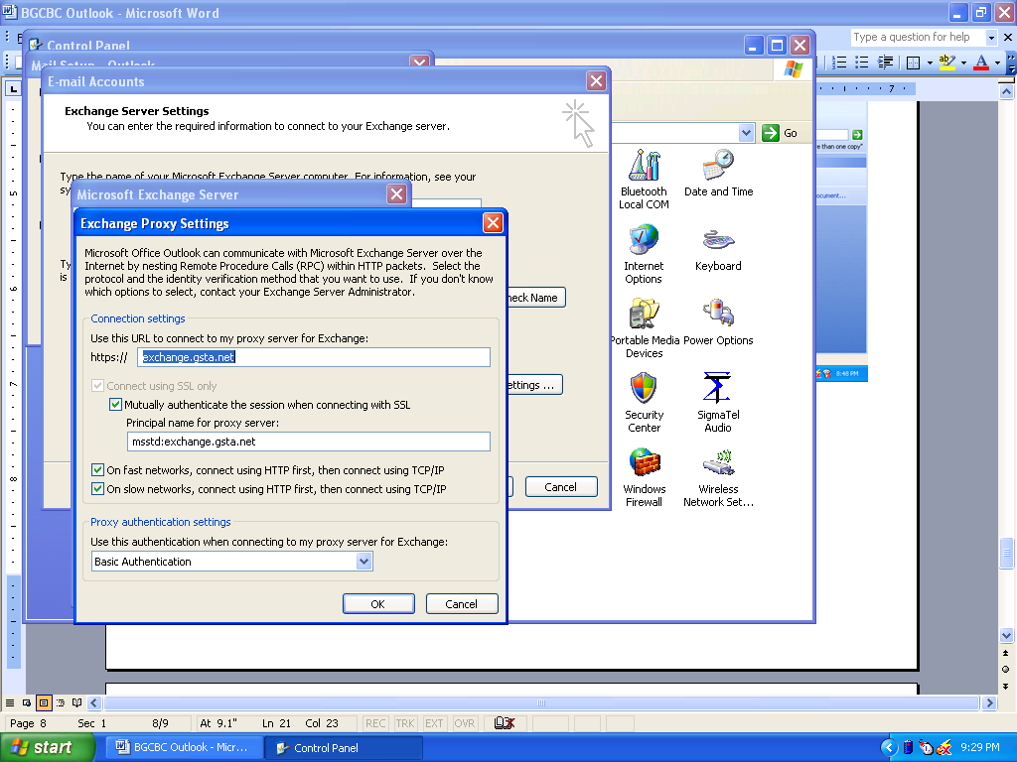

  - You have now entered all the information necessary to use outlook from a remote location. Click [OK], Click [OK], Click [Next], Click [Finish]
  - Close outlook and wait for it to completely finish.
  - From now on, every time you open outlook you will be asked for a username and password. Use the following format
USERNAME: [ EXCHANGE\username]
PASSWORD: [your password]
For example if your username was jsmith then you would enter: EXCHANGE\jsmith for the username and your password in the password box.

Outlook 2007 – VISTA/Windows 7 configuration:

To configure outlook 2007 you must complete the installation of the secure certificate into your internet explorer then configure outlook.

- User Password Setup
  - Go to the Control Panel and click on Users Accounts
  - Click on Manage your Credentials from the left side of the screen (fig. 0)
  - 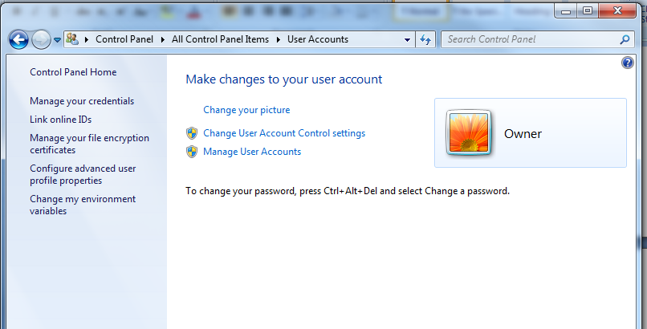Click on Add a Windows Credential
  - Fill in the information (with your username) (fig. 0a)
  - Server: exchange.gsta.net
  - Username: exchange\mjones
  - Password: <your password>
  - Click OK
  - Fig. 0a
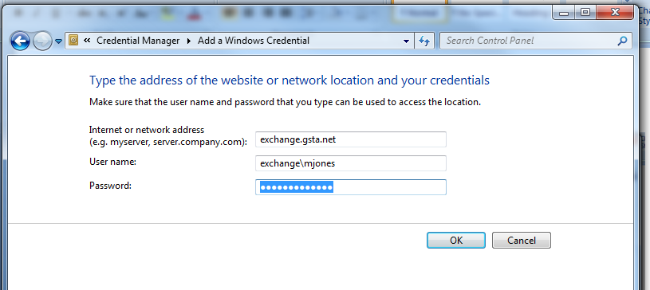

  - Click on Add a Windows Credential
  - Fill in the information (with your username) (fig. 0b)
  - Server: mail.exchange.gsta.local
  - Username: exchange\mjones
  - Password: <your password>
  - Click OK
  - Return to the control panel
  - Fig. 0b
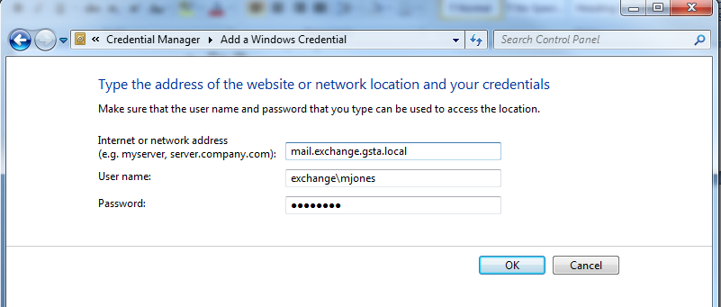

- Outlook configuration
  - Go to the control panel and click on the mail icon (fig. 1) Note that if you don’t see the mail icon then look at the left side of the screen and click [Switch to classic view]. If you still can’t see the mail Icon then this must be the first time that you setup outlook in your computer, if so then close the control panel and double click on Outlook Icon and follow the steps to add a new Microsoft Exchange Account.. Note: Vista 64 – the mail icon will be in a sub folder of the control panel called [View 32-bit Control Panel items]

Fig. 1
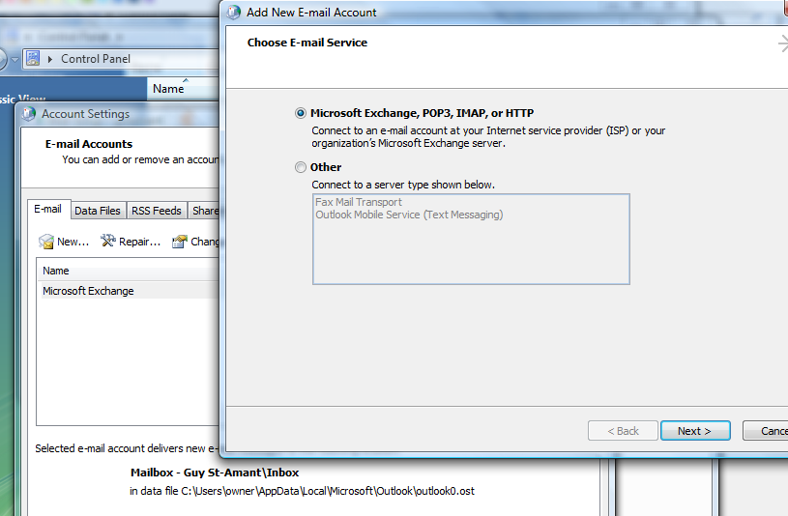

  - Click on the button that says [E-mail accounts]
  - Select the radio button that says [Add a new e-mail account] and click [Next]. Fig. 1
  - Select the box that says [x] Manually Configure server

Fig. 2
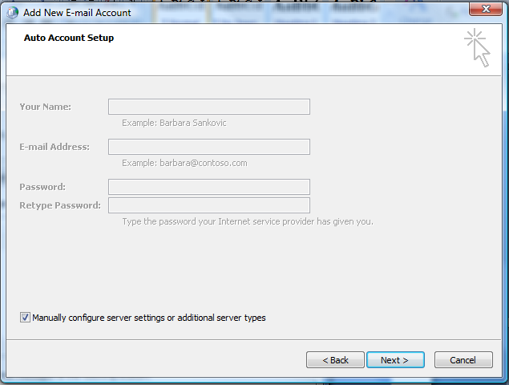

  - Select the radio button [Microsoft Exchange Server] and click [Next]. Fig. 3

Fig. 3
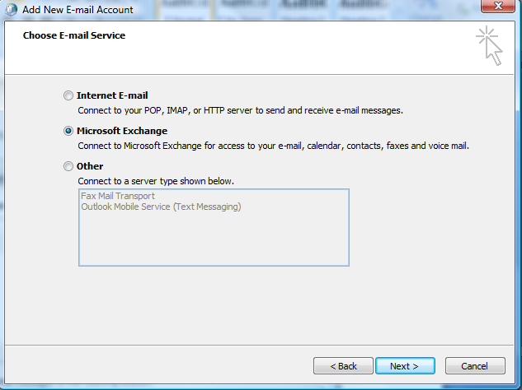

  - Enter the following information for the Microsoft Exchange Server: mail.exchange.gsta.local
Leave the box checked that says Use Cached Exchange Mode
Enter your username as assigned by the corporate office.
Note: if you get prompted by a popup box for your username and password, please click cancel for now. Fig. 4

Fig. 4
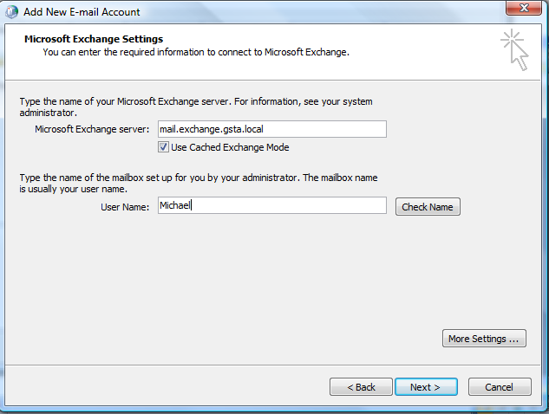

  - Click on the button that says [More Settings…]
  - Once you enter the more settings area click on the tab [Advanced]
  - Check the box that says Download Public Folder Favorites [x] Fig. 5

Fig. 5
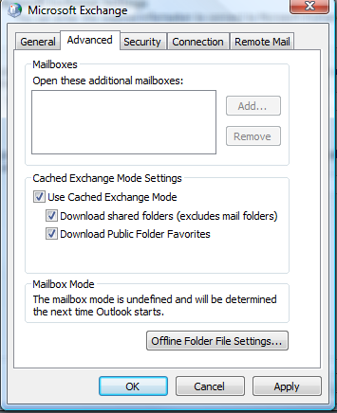

  - Click on the [connection] tab.
  - Check the box that says [Connect to my Exchange mailbox using http] [x]
  - Click on the button that says [Exchange Proxy Settings…] Fig. 6

Fig. 6
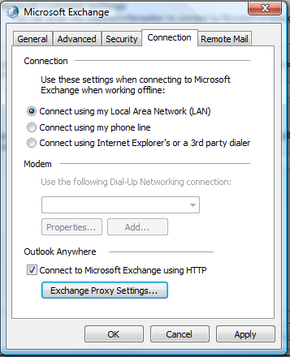

  - In the box that says [Use this URL to connect to my Exchange server] enter the following: exchange.gsta.net
  - Check the box that says [Mutually authenticate this session when connecting with SSL]
  - In the box that says [Principal name for the Proxy Server]: enter the following: msstd:exchange.gsta.net
  - Check the box [On Fast networks….] [x]
  - Check the box [On Slow networks …] [x]
  - Choose NTLM Authentication for the
[Proxy Authentication settings]. Fig. 7

Fig; 7
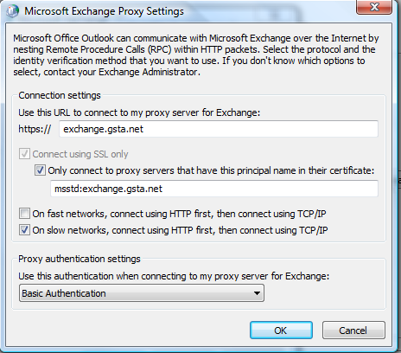

  - You have now entered all the information necessary to use outlook from a remote location. Click [OK], Click [OK], Click [Next], Click [Finish]
  - Close outlook and wait for it to completely finish.
  - From now on, every time you open outlook you will be asked for a username and password. Use the following format
USERNAME: [ EXCHANGE\username]
PASSWORD: [your password]
For example if your username was jsmith then you would enter: EXCHANGE\jsmith for the username and your password in the password box.

Guy St-Amant Aug 4, 2011

